
Capstone Portfolio Template (2025-2026)
school name: fathalla international applied technology school

Grade: 11
Project Title: spot
Team Code:W032526

(Team code includes school code, academic year, and team number)
Team Members:
Name | Student Code
Ahmed Alaa Ahmed Ali | J0324127
Belal Rezk Mohamed | J0324106
Malak Ahmed Saad | J0324125
Sohaip Osama Khalil | J0324109
Yousef Mohamed Metwally | J0324120

Section 1: Introduction and Challenge Review
Introduction
- What is the challenge or problem your project will solve
The idea is to conserve unintended electricity.
- What are the roles of each team member, describing how these roles will be rotated?
1- Ahmed: leader: role as a leader is to guide the team, organize the work, and make sure we achieve our goal successfully.
2 - sohaip: Researcher :role as a researcher is to collect accurate information, analyze it, and support the project with strong and reliable data.
3 - malak: documentation:role in documentation is to record all project details clearly and organize the information in a professional and structured way.
4- belal: presenter:role in documentation is to record all project details clearly and organize the information in a professional and structured way.
5 - youssef: researcher, documentation:role in documentation is to record all project details clearly and organize the information in a professional and structured way.

Empathy – Understanding User Needs
- Who are the users you are designing solution for?
We are designing this solution for:
Warehouse Workers
1-They need proper lighting only when they are working in a certain aisle.
2-The system ensures safe visibility without wasting energy.
- Warehouse Managers / Supervisors
1-They benefit from the energy-saving reports.
2-The data helps them monitor electricity usage, detect faults, and manage warehouse operations more efficiently.
- Hypermarket / Warehouse Owners
1-They want to reduce operational costs.
2-The solution helps them save electricity and prolong the lifetime of lighting units.
- Maintenance Teams
1-They use system reports to identify sensor malfunctions or electrical issues early.

- What are their needs and challenges?
1. Warehouse Workers
Needs:
1-Clear, bright lighting when working in any aisle.
2-A safe environment with no sudden darkness that may cause accidents.
Challenges:
1-Lights often stay on all day, causing heat, discomfort, or glare.
2-Workers may struggle in poorly lit areas if lights are not managed properly.

2. Warehouse Managers / Supervisors
Needs:
1-Accurate monitoring of energy usage.
2-A system that automatically adjusts lighting without manual control.
3-Reports showing areas with high activity or potential issues.
Challenges:
1-Hard to track how much energy is being wasted.
2-Difficult to detect lighting or sensor failures early.
3-Managing large warehouses with many aisles takes time and effort.

3. Warehouse / Hypermarket Owners
Needs:
1-Reduce electricity costs.
2-Improve overall warehouse efficiency.
3-Extend the lifetime of lighting units to save maintenance costs.
Challenges:
1-High monthly electricity bills due to constant lighting.
2-Replacing burnt-out lights frequently because of overuse.
3-Managing large spaces with many light sources.

4. Maintenance Teams
Needs:
1-Receive alerts about sensor errors or electrical issues.
2-Reduce the number of breakdowns caused by lights switching off/on too often.
Challenges:
3-Inspecting every aisle manually is time-consuming.
4-Detecting electrical faults late leads to bigger issues

- How will you gather information about their needs?

We will collect information using the following methods:
1- Interviews with workers in supermarkets to understand common weight-related issues.
2- Surveys for customers to ask how often they face wrong measurements.
3- Observations by watching how people use scales during shopping.
4- Online research to check common scale problems and user complaints.

Connecting to SDGs
- Which Sustainable Development Goals (SDGs) are related to your project?
1- goal 8: decent work and economic growth
2- goal 9: industry innovation and infrastructure
3- goal 12: responsible consumption and production
4- goal 17: partnerships for the goals

Organizing User Needs
- What user needs have you identified from your research?
The need to reduce unnecessary energy consumption
1- Many aisles have lights running 24/7 even when empty, leading to high electricity waste.
- The need for automatic lighting control
1-Workers and managers need a system that adjusts lighting automatically based on movement, heat detection, and natural light.
- The need for safe working conditions
1-Workers need consistent, bright lighting when present, without sudden darkness or delays in lighting.
- The need to protect lighting units from damage
1-Frequent turning on/off burns out lights quickly, so users need a system that dims instead of fully switching off.
- The need to take advantage of natural light
1-If sunlight enters the warehouse, users need the artificial lights to adapt and reduce brightness automatically.
- The need to optimize lighting in long aisles
1-When workers stay in an aisle for a long time, they need the system to reduce lighting in empty areas while keeping their work area fully lit.
- The need for monitoring and reporting
1-Managers need weekly reports showing:
2-Energy saved
3-How often lighting was increased or reduced
4-Where sensor activity happened
5-Any potential sensor malfunctions or upcoming electrical issues
- The need to reduce maintenance workload
1-Maintenance teams need early warnings when a sensor or lighting unit starts failing.
- What are the common themes or patterns in user needs?
1. Energy Efficiency
All users — owners, managers, and maintenance teams — share a common need to reduce electricity waste and lower operational costs.
This appears in:
1-Reducing unnecessary lighting
2-Using natural light
3-Dimmed lighting instead of constant full brightness

2. Automation
Users want lighting to adjust automatically without manual work.
Patterns include:
1-Sensors detecting movement or heat
2-Automatic dimming or increasing brightness
3-Automatic reporting

3. Safety & Visibility
Warehouse workers consistently need safe, clear lighting.
Pattern includes:
1-100% brightness when workers are present
2-No sudden full shut-off
3-Maintaining minimum 20% light for visibility

4. Operational Efficiency
Managers and owners want the warehouse to run smoothly.
Patterns include:
1-Optimizing lighting in active vs. inactive areas
2-Reducing the workload of staff who would otherwise control lighting manually

5. Maintenance & Reliability
A recurring theme is reducing technical problems and predicting failures.
Patterns include:
1-Reports about malfunctioning sensors
2-Early warnings for electrical issues
3-Protecting lights from burnout by avoiding frequent on/off cycles

Defining the Problem
- What is the final problem statement for your project?
1-Large warehouses and hypermarket storage areas waste significant amounts of electricity because their lighting systems stay on at full brightness even when aisles are empty. Workers, managers, and owners need a smarter, automated system that can detect activity, adapt to natural light, and reduce lighting in unused areas without compromising safety. The absence of real-time monitoring and weekly reports also makes it difficult to track energy usage, detect malfunctions early, and manage operations efficiently.
2-Therefore, there is a need for an intelligent sensor-based lighting solution that automatically adjusts brightness, saves energy, improves safety, and provides detailed analytics to warehouse managers.

- What impact will solving this problem have on users and the market?
1. Impact on Users

1- Warehouse Workers
1-Safer working environment with consistent, automatic lighting.
2-Better visibility without sudden darkness or overly bright lights.
3-More comfortable working conditions.

2-Warehouse Managers
1-Less time spent manually managing lighting.
2-Access to accurate weekly reports that help with planning, monitoring activity, and detecting problems early.
3-Smoother operations and easier decision-making.

3- Warehouse / Hypermarket Owners
1-Significant reduction in electricity bills.
2-Lower maintenance costs due to less burnout of lighting units.
3-Longer lifetime for equipment and lighting systems.

4-Maintenance Teams
- Faster identification of sensor or electrical issues.
- Reduced workload because the system provides automatic alerts and diagnostic data.
- Less emergency repairs due to proactive notifications.

2. Impact on the Market

• Increased Adoption of Smart Energy Systems
- Warehouses and hypermarkets will move toward automated lighting solutions instead of traditional manual systems.

• Competitive Advantage
- Businesses that use the system will save money and run more efficiently, making them more competitive in the retail and logistics sectors.

• Cost Savings at Large Scale
- If widely adopted, companies with hundreds of warehouses can save millions in energy and maintenance.

• Environmental Impact
- Lower electricity consumption means reduced carbon footprint.
- Supports sustainability goals, which many companies now prioritize.

• Better Data-Driven Decisions
- The generated reports introduce analytics to warehouse lighting, a market that currently lacks smart data tools.

Section 2: Researching Solutions and Generating Ideas
- What are some possible solutions to the problem?
1. Motion & Heat Sensor–Based Lighting System
A network of sensors is installed along warehouse aisles.
They detect movement, presence, and temperature changes and automatically adjust lighting levels.
How it helps:
- Full brightness when workers are present
- Dimmed lighting (20%) when aisles are empty
- Significant energy savings

2. Smart Lighting with Natural Light Detection (Photocell Sensors)
Lighting units include sensors that measure natural sunlight entering the warehouse.
How it helps:
- Automatically reduces artificial lighting when sunlight is available
- Prevents over-lighting
- Lower electricity usage during daytime

3. Predictive Lighting System (AI/Timing Patterns)
The system learns patterns of worker activity—peak hours, busy aisles, or specific routines—and adjusts lighting in advance.
How it helps:
- Lights are ready before workers even enter
- Reduces unnecessary lighting in empty aisles
- Improves workflow efficiency

4. Zoned Lighting Control
Instead of controlling an entire aisle, the warehouse is divided into zones.
How it helps:
- Only the zone with active workers gets full brightness
- All other zones remain at eco-lighting (20%)
- More precise control and higher energy savings

- Have any similar solutions been tried before?

1. Motion-Activated Lighting (Basic Sensors)
Some warehouses use simple motion sensors that switch lights on when movement is detected.
Limitations:
- Lights turn completely off when no motion is detected → causing faster burnout.
- No detection of heat or long-term presence.
- No gradual dimming (only ON/OFF).
- No reporting system.

2. Photocell Light Sensors (Natural Light Detection)
Common in streetlights and some modern buildings.
Limitations:
- Only adjusts brightness based on sunlight.
- Cannot detect workers or activity in aisles.

3. Smart LED Systems with Dimming
Some facilities use dimmable LEDs controlled manually or by simple timers.

Limitations:
- Not automated based on activity.
- Cannot detect patterns or duration of workers staying in the aisle.

4. Building Management Systems (BMS)
Large buildings sometimes use centralized systems to control lighting and HVAC.
Limitations:
- Expensive and complex.
- Not optimized specifically for warehouse aisles.
- Usually does NOT analyze worker movement zone-by-zone.

5. Energy-Saving Policies (Manual Switching)
Some stores instruct staff to turn off lights in unused areas.
Limitations:
- Human error → people forget.
- Not practical in large warehouses.

- Why is your solution the best option?

1. It provides maximum energy savings without risking worker safety
Unlike systems that turn lights fully off, our solution dims lighting to 20%, which:
- Keeps aisles visible
- Protects workers from accidents
- Prevents LED burnout caused by repeated ON/OFF cycles
This gives the perfect balance between safety and energy reduction.

2. It uses multiple types of sensors for accuracy
Most systems rely on just ONE sensor.
Our solution uses a combination of:
- Motion sensors
- Heat sensors
- Natural light sensors

3. It adapts based on worker behavior—not only on movement
The system learns when workers stay in an aisle for long periods (30–60 minutes) and:
- Keeps their zone at 100%
- Reduces lighting in empty zones
- Saves more electricity while supporting productivity

4. It is fully automated — no manual control required
Managers and workers don’t need to switch lights on or off.
The system handles everything automatically, which:
- Eliminates human error
- Saves time
- Ensures consistent lighting behavior

5. It includes a complete reporting system
The system generates weekly reports showing:
- How much electricity was saved
- How many times lighting increased or dimmed
- Which aisles were active
- Whether any sensor is malfunctioning
- Early warnings about electrical issues

What will your prototype look like?
Our prototype will be a small-scale smart warehouse lighting model that demonstrates how the intelligent system works in real life.

It will include:
- Mini Warehouse Model
A physical model representing warehouse aisles using cardboard or foam board.
Each aisle will have small LED lights installed above it to simulate real warehouse lighting.
- Sensor System
The prototype will include:
- Motion sensors to detect movement in each aisle
- Heat (presence) sensors to detect if a worker stays in one area
- Light (photocell) sensors to detect natural light
These sensors will be connected to a microcontroller (such as Arduino or similar board).
- Zoned Lighting Demonstration
Each aisle will be divided into zones:
- When movement is detected → lights turn to 100% brightness
- When no movement is detected → lights dim to 20% instead of turning off
- Control Unit
A small control board (microcontroller) will:
- Receive signals from sensors
- Adjust LED brightness automatically
- Simulate energy-saving logic
- Monitoring Dashboard (Digital Prototype)
We will also create a simple digital dashboard (on a laptop or web interface) that shows:
- Active aisles
- Energy usage
- Number of lighting adjustments
- Alerts for sensor malfunction
- Demonstration Scenario
During the presentation:
- A team member will simulate a worker walking through aisles
- The lights will automatically brighten in active zones

- How will you test your prototype?
We will test our prototype using structured testing scenarios to make sure the system works correctly, safely, and efficiently.

1. Movement Detection Test
- Expected Result:
- The lights in that zone increase to 100% brightness.
- Other zones remain dimmed at 20%.

2. Long Presence Test
- Expected Result:
- The active zone remains at full brightness.
- Empty zones gradually dim to eco-lighting mode.

3. No Movement Test
- Expected Result:
- Lights reduce to 20% brightness.
- They do NOT turn completely off.

4. Natural Light Test
- Expected Result:
- Artificial lighting automatically reduces brightness.
- Energy consumption decreases.

5. Sensor Failure Test
- Expected Result:
- The system sends an alert to the dashboard.
- The issue appears in the report.
- What materials do you need to build your prototype?
1. Hardware Components
- Microcontroller (Arduino or similar board)
To control the sensors and lighting system.
- Motion Sensors (PIR sensors)
To detect movement in each aisle.
- Heat / Presence Sensors
To detect long-term worker presence.
- Light Sensors (Photocell / LDR sensors)
To measure natural light levels.

2. Prototype Structure Materials
- Cardboard or Foam Board
To build the warehouse aisle model.
- Plastic Sheets or Small Boxes
To simulate storage shelves.
- Glue, Tape, and Basic Craft Tools
To assemble the physical model.

Preliminary Feedback
- What feedback did you receive from the panel?
- The idea was accepted and then we started working on it
- What changes did you make based on the panel’s feedback?
Made us think better to think for the designing as a mobile app to gather more information about IOT and connect it to the challenge
Section 3: Prototyping
Design the Prototype
- Draw or describe the final design of your prototype with dimensions.

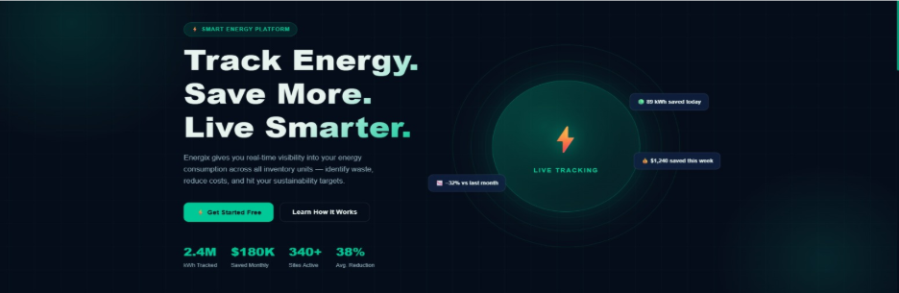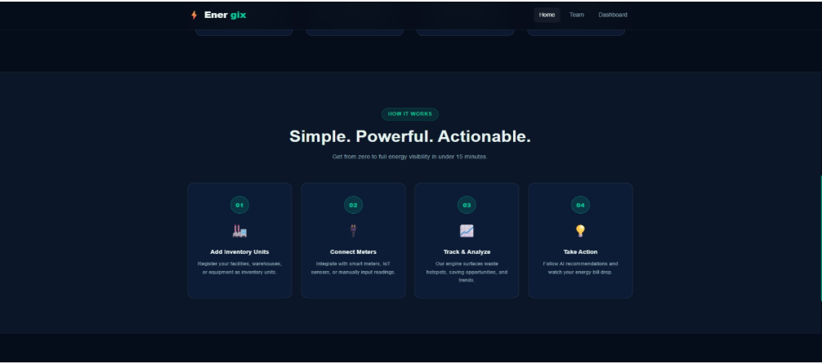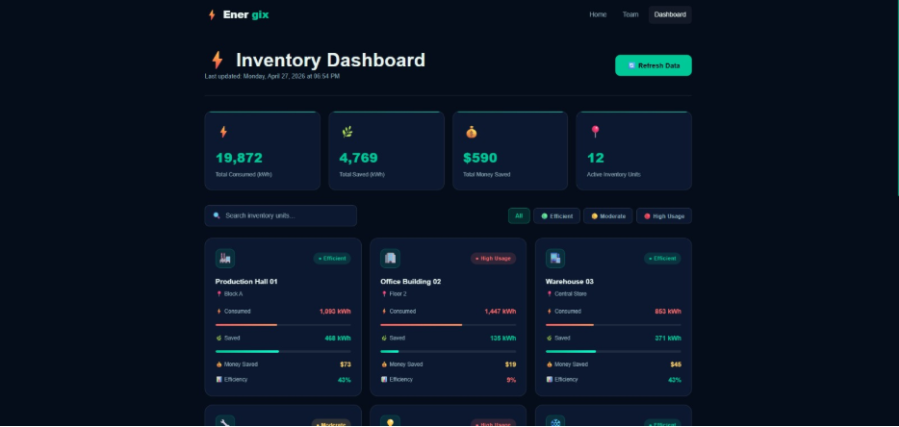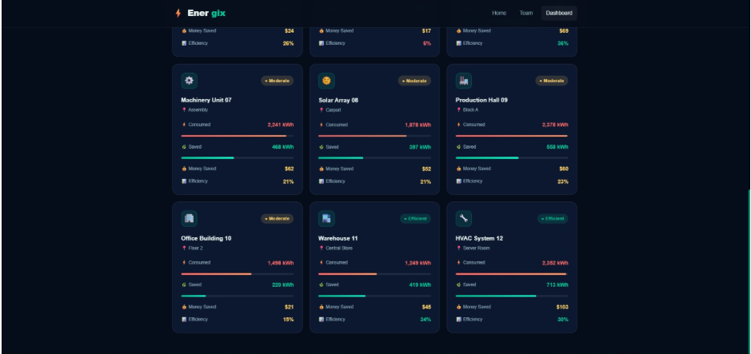
- What is the final materials list needed to build your prototype?

Microcontroller: 1x Arduino Uno or Mega.
Sensors: 2x PIR Motion Sensors, 2x LDR (Photoresistors), 1x DHT11 (for heat/temp).
Lighting: 6x High-brightness White LEDs with 220Ω resistors.
Connectivity: Jumper wires and 1x Breadboard.
Structure: 2x Large Foam Board sheets, Hot glue, and Black spray paint (for internal aisle realism).
Power: 9V Battery or USB Power Bank.

- What challenges do you expect during testing?
Sensor Sensitivity: The PIR sensors might trigger from movement outside the intended aisle. 2. Ambient Light Interference: Natural light from windows during the demo might confuse the LDR sensor. 3. Code Logic: Ensuring the transition from 100% to 20% brightness is smooth (PWM fading) rather than a harsh flicker.
Building the Prototype
- What challenges did you face during building the prototype? How did you overcome them?
The LEDs were either fully ON or fully OFF.
We used PWM (Pulse Width Modulation) pins on the Arduino to allow for the 20% dimming state.
Challenge: Wiring became messy in the small model.
Solution: We color-coded the wires (Red for Power, Black for Ground, Yellow for Signal) to track connections easily.

Section 4: Testing the Prototype and Refining Solutions
- What tests did you run on your prototype?
Moved a hand through the aisle to see if LEDs jumped to 100%.
The "Timeout" Test: Left the aisle still for 30 seconds to ensure it dimmed to 20%.
The "Flashlight" Test: Shone a light on the LDR to see if the system lowered the artificial light output.

- What feedback did you receive from testing?
Testing showed that 20% light was perfect for safety, but the sensors needed "blinders" (small tubes) so they wouldn't detect movement in the neighboring aisle
Provide a visual representation of your data and results.
Create a simple bar chart comparing "Traditional Lighting (Always 100%)" vs. "Spot System (Avg. 35% usage over time)."

Include a chart, graph, or any visual to display your results.
- How did you improve your prototype based on testing?
We added a small LCD Screen to the physical prototype to display the current "Mode" (Eco/Active) and the estimated "Watts Saved" in real-time for the user to see without the dashboard.

Section 5: Refining the Business Model
Use this template to complete your business model for the project:
(Energy Sever)
School Name |  | Project Name |  |  | Group No.
Business Model Canvas
Key Partners | Key Activities | Value Propositions |  | Customer Relation |  | Customer Segment
- Electrical Equipment Supplier  - Ware house operators | - Sensor in Installation  - Smart Monitoring  - Report Generation | - Executable Report  - Cost Efficiency  - Reduce Electricity  - Using AI For IOT |  | - Large scale warehouse  - Hypermarket  Chains  - Automated  Support |  | - 1-B.Owner class(A) who have huge inventory of factories store or process products  - 2- B.Owner Class (B) who haves small inventory or small factories
- Electrical Equipment Supplier  - Ware house operators | Key Resources |  |  | Channels
- Electrical Equipment Supplier  - Ware house operators | - Hardware  - Control Software  - Reporting System |  |  | - Direct Sales  - Maintenance alerts
Cost Structure |  |  | Revenue Streams
- Sensor Procurement  - Software development  - maintenance  - AWS/Cloud hosting |  |  | - Installation Fees  - Service / Subscription

Section 6: Communication
Transferred academic, Technical, and key Competences:
- Which competences did you use as related to your Capstone? Explain how each competence was used in your Capstone?
- Literacy Competence:
- Ability to read, write, and interpret information critically.
- Foundation for communication, learning, and participation in society.
- Digital Competence:
- Confident, critical, and responsible use of digital technologies.
- Includes online safety, data literacy, and adapting to new digital tools.
- Entrepreneurship Competence:
- Creativity, innovation, and risk-taking.
- Ability to turn ideas into action and manage projects effectively.

Story to communicate:
- What is the story behind your project?
The idea is to rationalize unintentional electricity consumption in warehouses and storage facilities that consume large amounts of electricity 24 hours a day, thus saving energy and money, and consequently reducing the cost of energy consumption.

- What did your team learn from this project?
Throughout our Capstone experience, we strengthened essential lifelong learning competences. We improved our literacy competence by clearly communicating ideas through written reports and presentations. Our digital competence grew as we used online tools to collaborate, research, and organize project materials. Most importantly, we developed entrepreneurship competence by solving problems creatively, managing tasks independently, and turning ideas into action. This project taught us how to work as a team, adapt to challenges, and take ownership of our learning.

- How did your project impact your users and the market?

Providing electricity to the market without affecting the consumer, with a particular focus on weekly reports to determine the amount of electricity that has been provided.

References
- List your sources in APA format as follows:
1. U.S. Department of Energy – Federal Energy Management Program "Wireless Occupancy Sensors for Lighting Controls" 🔗 https://www.energy.gov/femp/articles/wireless-occupancy-sensors-lighting-controls-applications-guide-federal-facility
2. U.S. DOE – Better Buildings Solution Center "Wireless Sensors for Lighting Energy Savings" (Guidance PDF) 🔗 https://betterbuildingssolutioncenter.energy.gov/sites/default/files/attachments/Wireless-Sensors-Guidance.pdf
3. EnOcean Alliance "Wireless Lighting Controls: A Total Cost Analysis" — Warehouse Payback Study 🔗 https://www.enocean-alliance.org/wp-content/uploads/2016/11/Whitepaper__wireless_lighting_controls_payback.pdf
4. AGC Lighting "High Bay Light with Occupancy Sensor Saving Energy in Warehouse" — PIR & Microwave Sensors 🔗 https://www.agcled.com/blog/high-bay-light-with-occupancy-sensor-saving-energy-in-warehouse.html

